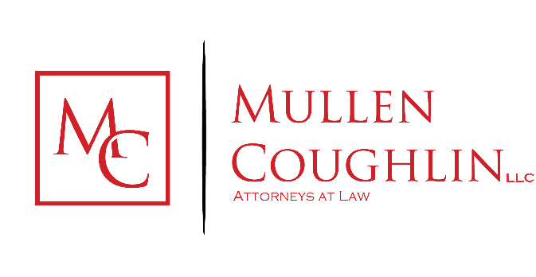
Gregory J. Bautista  Office: (267) 930-1509  Fax: (267) 930-4771  Email: gbautista@mullen.law | 1266 E. Main Street, Soundview Plaza,  Suite 700 R  Stamford, CT 06902

May 8, 2024

We represent Bodyartforms LLC (“Bodyartforms”) located at 1966 South Austin Avenue, Georgetown, Texas 78626, USA, and are writing to notify your office of an incident that may affect the security of certain personal information relating to one hundred seventeen (117) Maine residents. This notice will be supplemented with any new significant facts learned subsequent to its submission. By providing this notice, Bodyartforms does not waive any rights or defenses regarding the applicability of Maine law, the applicability of the Maine data event notification statute, or personal jurisdiction.

Nature of the Data Event

On March 7, 2024, Bodyartforms learned of potentially malicious activity involving their website checkout page. Bodyartforms immediately took steps to secure the website and began an investigation with the assistance of third-party cybersecurity specialists. The investigation recently concluded on April 22, 2024, and determined that customers who entered payment card information on the Bodyartforms website between October 16, 2023, and March 7, 2024, could have had their payment card information captured by an unknown party.

The information that could have been subject to unauthorized access includes name, billing address, payment card number, and security code.

Notice to Maine Residents

On May 8, 2024, Bodyartforms provided written notice of this incident to one hundred seventeen (117) Maine residents. Written notice is being provided in substantially the same form as the letter attached here as Exhibit A.

Other Steps Taken and To Be Taken

Upon discovering the event, Bodyartforms moved quickly to investigate and respond to the incident, assess the security of Bodyartforms systems, and identify potentially affected individuals. Bodyartforms is also working to implement additional safeguards, including utilizing a web vulnerability scanner and increasing firewall security. Additionally, Bodyartforms is performing a comprehensive website code review and patching all identified opportunities for future injection.

Additionally, Bodyartforms is providing impacted individuals with guidance on how to better protect against identity theft and fraud, including advising individuals to report any suspected incidents of identity theft or fraud to their credit card company and/or bank. Bodyartforms is providing individuals with information on how to place a fraud alert and security freeze on one’s credit file, the contact details for the national consumer reporting agencies, information on how to obtain a free credit report, a reminder to remain vigilant for incidents of fraud and identity theft by reviewing account statements and monitoring free credit reports, and encouragement to contact the Federal Trade Commission, their state Attorney General, and law enforcement to report attempted or actual identity theft and fraud.

Bodyartforms is providing written notice of this incident to relevant state regulators, as necessary.

Contact Information

Should you have any questions regarding this notification or other aspects of the data security event, please contact us at (267) 930-1509.

Very truly yours,

Gregory J. Bautista of
MULLEN COUGHLIN LLC

